RDA2 REPORT

June 20, 2026
Linda C.
RDA2, CAR-NA
Linda C.
RDA2, CAR-NA

Gratitude
I am grateful for the opportunity to attend the 2026 World Service Conference in California. The experience strengthened my understanding of world services, consensus-based decision making, and the worldwide Fellowship of Narcotics Anonymous.

We Women Do Recover
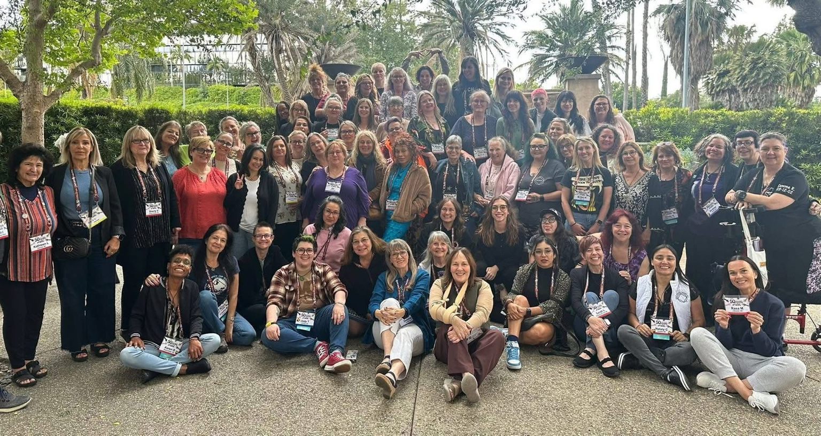
Connecting with women from around the world reminded me that recovery is possible for all addicts.

Making Memories and Carrying Our Region's Voice
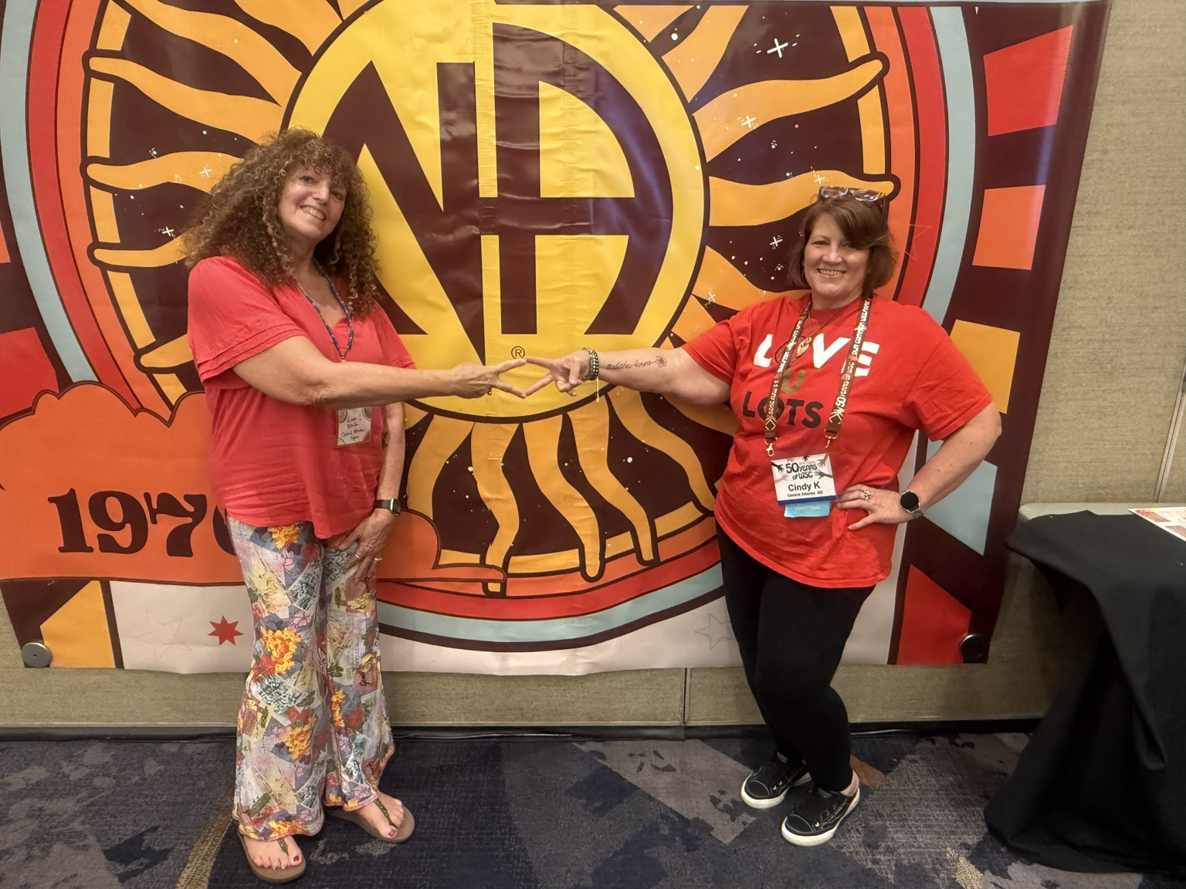
Representing CAR-NA and carrying our region's voice was a privilege.

Learning from the Gallery
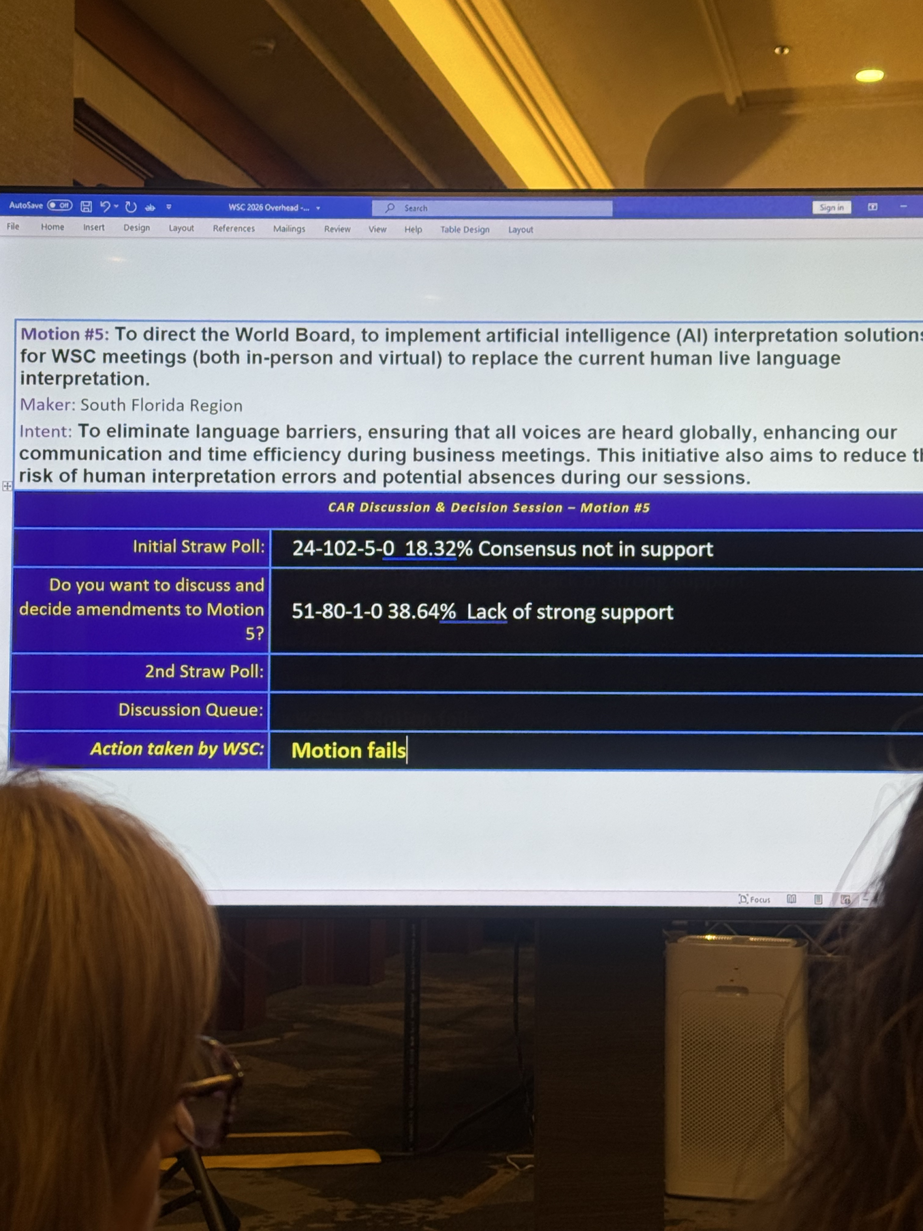
Even while sitting in the gallery, I learned about consensus-based decision making and conference business.

We Are in the Miracle-Making Business
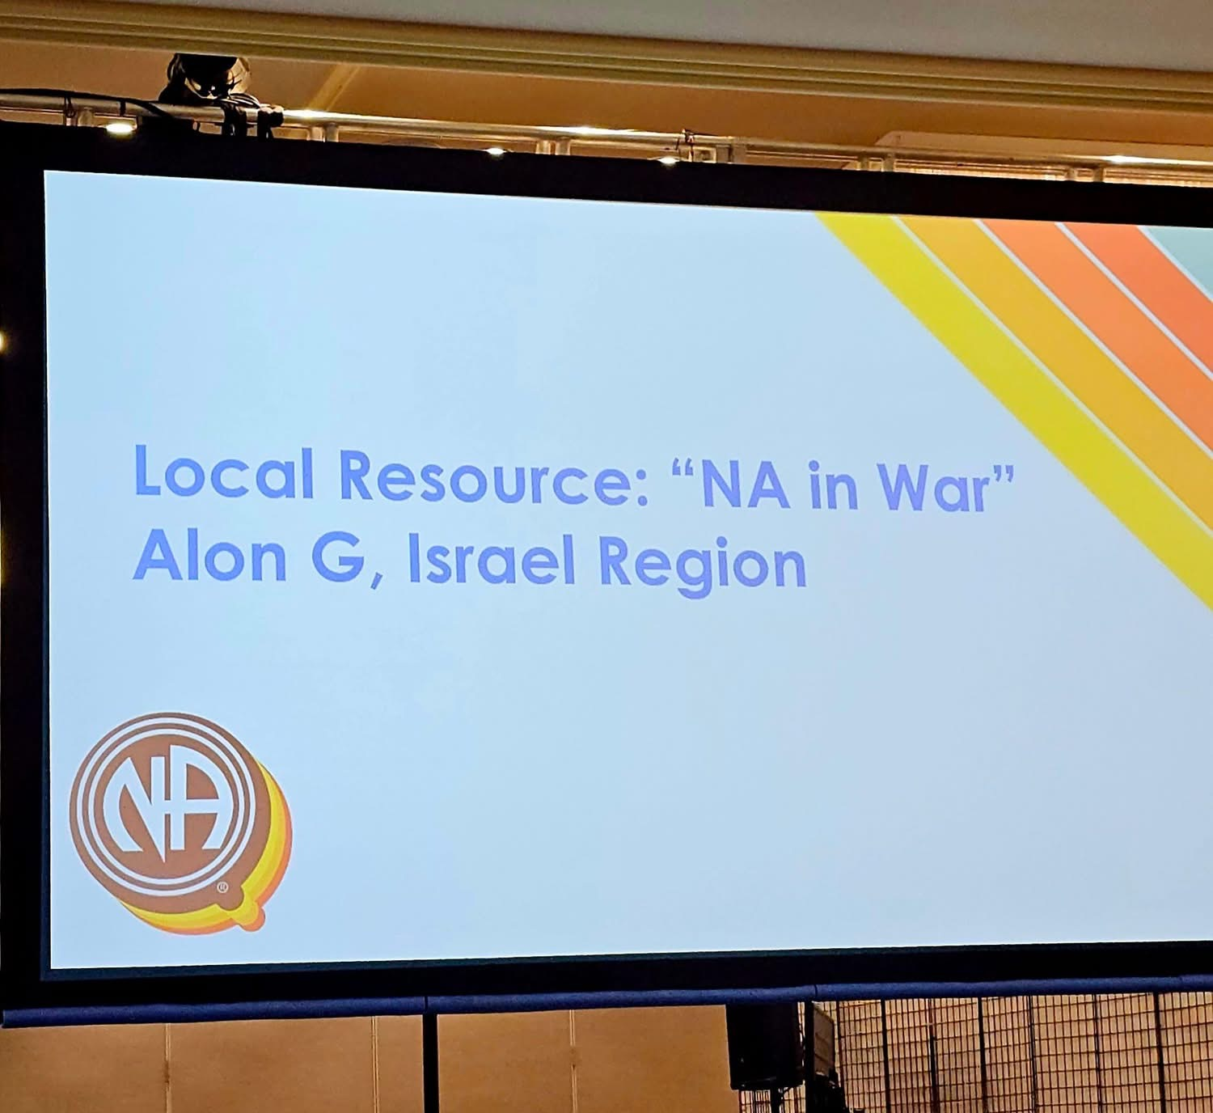
The presentation 'NA in War' demonstrated how members work together across borders and conflicts.

A Seat at the Table
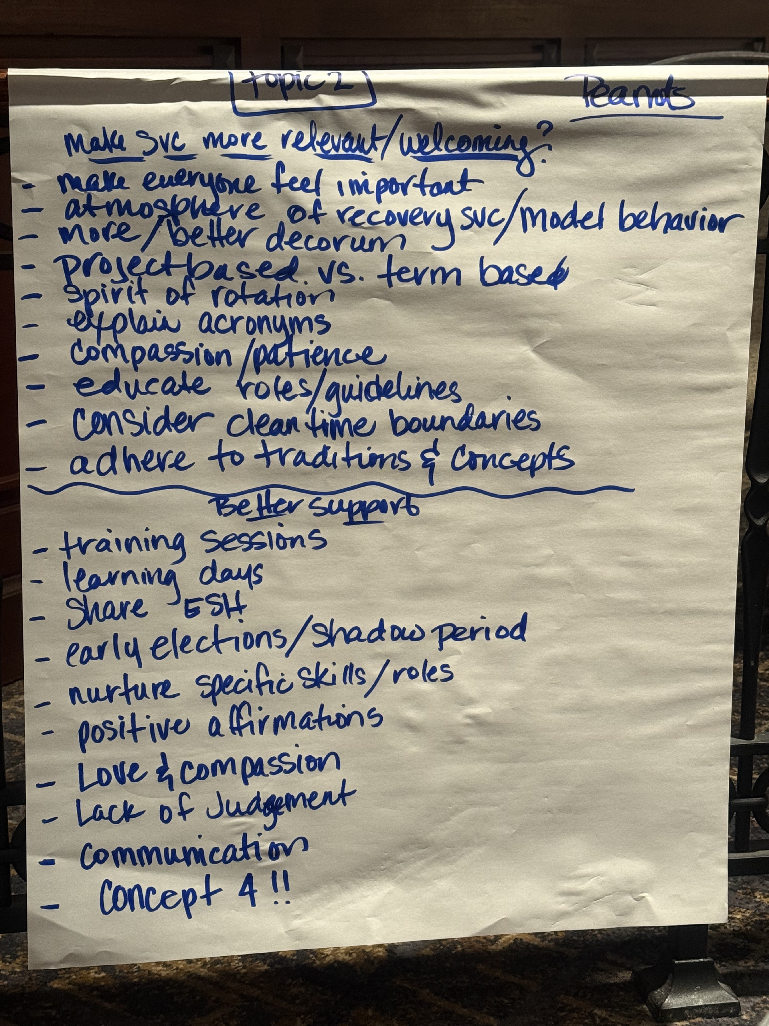
Participating in breakout sessions with Alternate Delegates helped me learn and contribute.

Expense Reimbursement and Future Service
I will be submitting my World Service Conference expense reimbursement request. I also intend to submit proposed expenses for attendance at the Northeast Zonal Forum and request consideration for participation in the Multi-Zonal Forum.
In Loving Service,
Linda C.
RDA2, CAR-NA

Delegate Coffee Hour
On June 8, 2026, I attended the Delegate Coffee Hour hosted by the Northeast Zonal Forum (NEZF) via Zoom. I participated in the conversation and appreciated the opportunity to connect with trusted servants throughout the zone.
During the event, I was honored to receive a registration to NESSNA for having the best coffee cup. This experience strengthened fellowship connections and encouraged continued service.

In Loving Service,
Linda C.
RDA2, CAR-NA

