Hospitals & Institutions
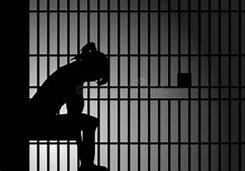
ORIENTATION
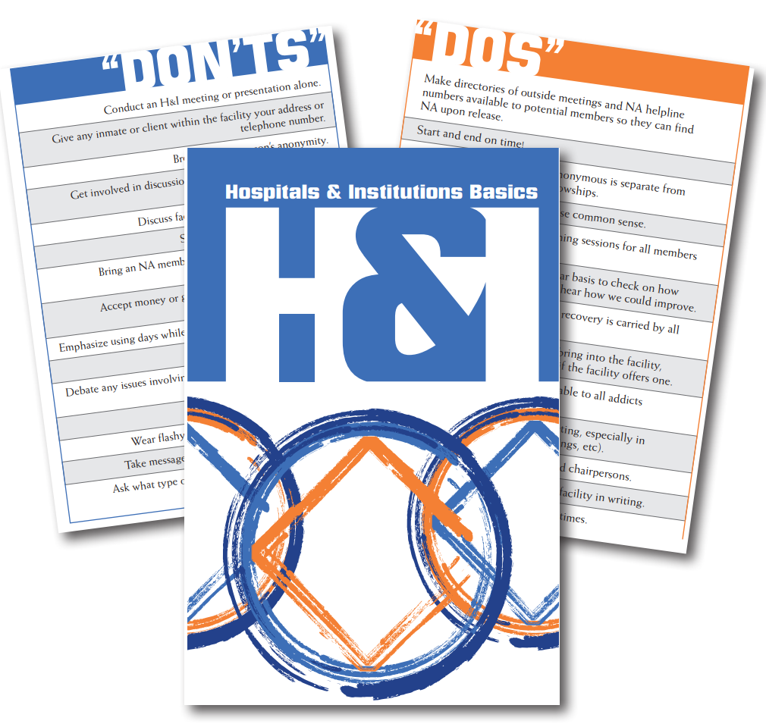
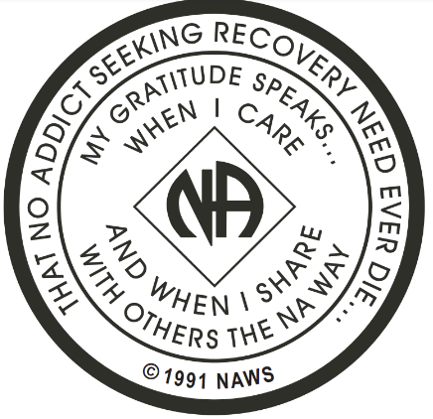
Learn how to help carry the message that no addict seeking recovery need die without having a chance to find a better way of life.

When: Sunday August 30, 2026
Where: St. James Catholic Church-Auxillary Building
55 Crosswinds Dr.
Charles Town, WV 25414
Time: 1:30 p.m. to 3:30 p.m.
Please arrive by 1:25 p.m.
Far right parking lot. Small building behind playground. Follow signs.
