Central Atlantic Region of Narcotics Anonymous
Planning Day Record and Regional Handoff | October 17, 2026
Working record prepared from photographs of flip charts and the facilitator’s account. Text in quotation marks generally follows the writing on the sheets; bracketed notes mark uncertain readings or editorial clarification. This document does not imply regional approval of projects.

At a glance
The group began with imagined positive news headlines, identified current strengths, gathered issues and opportunities for growth, grouped and prioritized issues, then developed goals and suggested approaches for the three selected priorities. The next steps are presentation to the region, project-plan development, regional consideration in December, and monitoring and evaluation of any approved projects.

1. Three prioritized issues, goals, and approaches

Priority 1 — Predatory behavior / meeting safety
Issue : “Predatory Behavior / Meeting Safety.”
Goal: “Meetings are safe and lack predatory behavior (space for all to recover)”
Suggested approaches:
- When current predatory behavior is communicated, the region asks: “Can we help?”
- Look at other resources already created (NA organizations).
- Be aware of the weight of our involvement; avoid persecution; do not step around areas.
- Make sure NA is not complicit in any predatory behavior.
- Create a locally focused “IP” on predatory behavior.
- Region creates mechanisms/resources to address predatory behavior. [This phrase also appears on the goal-development sheet.]
- Make members aware of and give access to resources that help create and maintain safe spaces.
- Come to a clear understanding of what predatory behavior is (sexual / power / money / etc.).
- Regularly scheduled speaker jams (not defined) and webinars.

Priority 2 — Lack of qualified members to fill service positions
Issue : “Lack of qualified members to fill service positions.”
Goal: “All positions are filled with qualified members.”
Suggested approaches:
- Provide time monthly at RSC for RCM orientation/training (handwritten addition: “bi-” above monthly; confirm intended frequency).
- Come up with a definition of “qualified.”
- Create “out of box” solutions / accessibility to bring more people into service.
- Examine guidelines to make service more accessible.
- Look into CBDM (consensus-based decision making).
- Direct outreach to sponsors
- Local “Human Resource Panel” and create a service “pool.”
- Review guidelines for positions’ practicality.
- People in positions help train/mentor successors.

Priority 3 — Lack of training, mentoring, and knowledge
Issue: “Lack of training/mentoring or knowledge.”
Goal: “Members are trained, knowledgeable and ready to mentor others.”
Suggested approaches:
- Examine / add to RCM training / orientation packets.
- Fun service workshops and cookouts (note: “not called workshops / learning days”).
- Bite-sized social media training videos / reels (local).
- “Train the trainer” workshops.
- Service workshops at cookouts / events.
- Fun service workshops - “Don’t call it a service workshop or learning day!!!”
- Coordinate with regional and area conventions
- Ask members (younger, older, all) how can we reach them, what would help get them involved?
- Plan events farther ahead and communicate them sooner
- Ask areas how they are doing / ask what do they need
- Area surveys or questions to send via RCMs -> GSRs -> Groups
- Contact those responding / interested personally

2. Planning-day process and prioritization
Process: (1) create positive newspaper/newsletter headlines; (2) list what is already going well; (3) list issues/opportunities for growth; (4) group issues; (5) prioritize the groups; (6) select the top 2–3 and write goals; (7) suggest approaches for each goal.

Imagined positive headlines — “Extra Extra Read All About It!”
- Quarterly PR learning days.
- CAR hosting first professions day with government/recovery professionals.
- NA membership doubles this year.
- Service opportunities available.
- Greater variety of fellowship.
- Young people more active in service.
- Old timers coming back to service.
- Page / Counties hold recovery rally [the wording and place names need verification].
- All RCM filled & guidelines read.
- CA PR connecting with higher education and professionals.
- Brain attracts members and rewriting of bylaws [handwriting uncertain; “education” appears in a side note].
- 2nd Tradition!
- Recovery is possible weekend block party.

What CARNA is already doing
- 2 day events — learning days.
- Rotate to different area/quadrants.
- VSI PR event
- Hybrid — open — bi-monthly.
- Using libraries.
- Fliers
- Conventions, campouts, Serenity by Shore.
- Experience.
- Teaching, encouraging — “UNITY.”
- Willingness to change.

3. Initial issues / opportunities for growth
- Lack of training.
- Warm bodies [clarified: “warm body syndrome,” electing members without adequate qualifications or preparation].
- Predatory behavior.
- Ensuring safety in meetings.
- Excitement for service & NA.
- Issues arise; unity surrounds situation [original wording unclear; unity later grouped with connection/ownership].
- 7th Tradition [clarified: member connection, ownership, and contributions of time/service, not only money].
- Lack of understanding what is discussed.
- Members being willing to read guidelines.
- Guidelines not practical / guidelines versus practical application.
- Communication flow (top to bottom) is broken.
- There is a disconnect between our primary purpose and service.
- There are not enough experienced members in service [clarified: experienced members may not be participating or know about needs].
- Personalities interfering with members getting involved.
- Lack of service rotation [discussion identified both too few members and reluctance to let go].
- Unchecked loud voices/opinions prevent discussion/change.
- Lack of outreach.
- Lack of area participation at RSC [not assumed to be a shortage of members].
- Areas struggle to fill service positions.
- Outlying areas not well supported.
- NA groups not following Traditions [placed with outreach/support].

Working groupings before prioritization
The discussion refined the categories to avoid assuming causes and to keep issues together only where goals could have related directions. The final working headings discussed were:
- Lack of Members in Service — filling positions, experienced members not participating, warm body syndrome, service rotation.
- Lack of Training — training and understanding service discussions.
- Lack of Area Participation at RSC.
- Breakdown in Communication.
- Safety in NA Meetings — predatory behavior and safety.
- Guidelines and Decision Making — practicality, participation, voices being heard, facilitation.
- Lack of Outreach — outlying-area support and groups needing Traditions resources.
- Lack of Connection and Ownership in NA — Seventh Tradition contributions, primary purpose, excitement, unity.

Grouped issue prioritization
1. Predatory behavior / meeting safety | 6 votes
2. Guidelines not practical; decision-making challenges with all voices heard/participating | 4 votes
3. Disconnect between primary purpose and service; lack of enthusiasm in service | 4 votes
4. Lack of qualified members to fill service positions | 8 votes
5. Communication flow is broken | 3 votes
6. Outlying areas not participating or supported | 3 votes
7. Lack of training/mentoring or knowledge | 6 votes

7. Next steps and accountability
Tomorrow — October 18, 2026 regional meeting | Present the three prioritized issues, their selected goals, and the suggested approaches. Make clear that approaches are proposals, not approved projects.  Task a planning ad-hoc committee with developing practical project plans for workgroups.
Before the December 2026 regional meeting | Planning Ad-hoc creates a project plan for each proposed project: define purpose and scope; specific activities; needed members/resources; lead and support roles; expected results; timeline and milestones; how progress will be measured; and how/when updates will be reported.
December 2026 regional meeting | Present project plans for regional consideration and vote. For approved plans, appoint or elect members to lead and participate in the workgroups.
Throughout each approved project | Monitor progress against milestones and intended outcomes; report regularly to the region; evaluate what is working, what needs adjustment, and whether the goal has been met.
At completion or agreed review points | Evaluate results, record lessons learned, and recommend continuation, changes, or closure to the region.

Appendix — original flip-chart photographs
The following images preserve the photographed source record, including text not fully legible in transcription. Images may overlap.

Photograph 1 — IMG_3634.jpeg
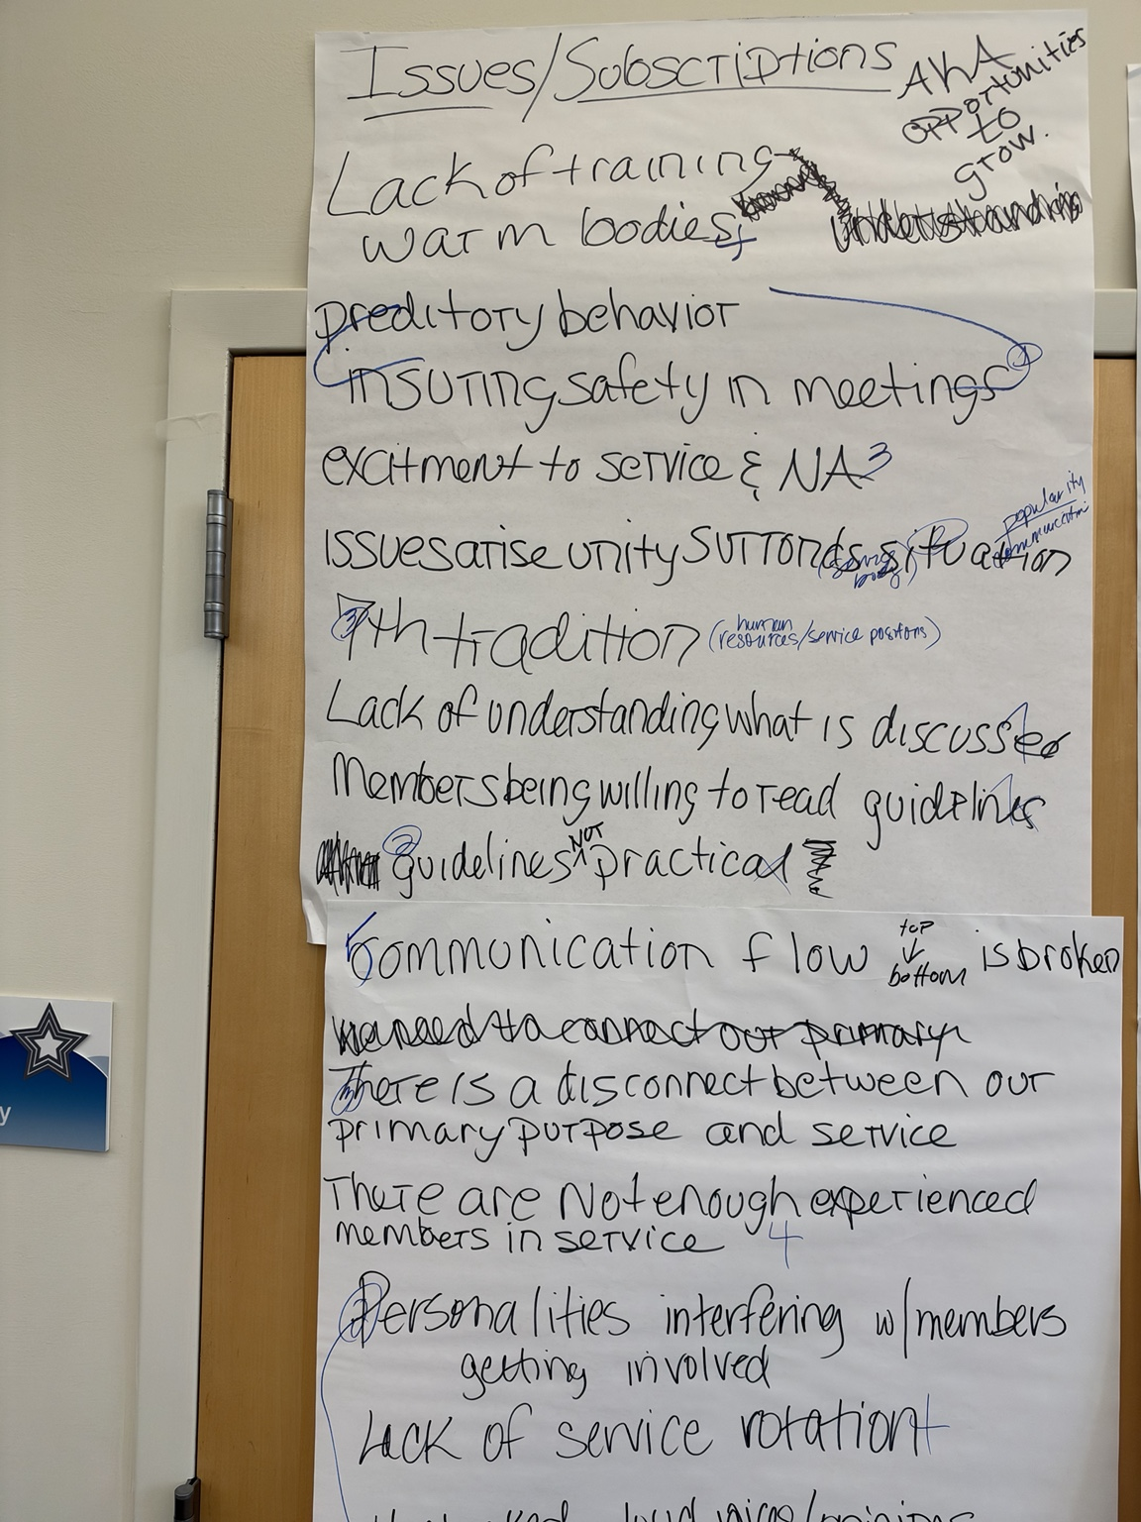

Photograph 2 — IMG_3635.jpeg
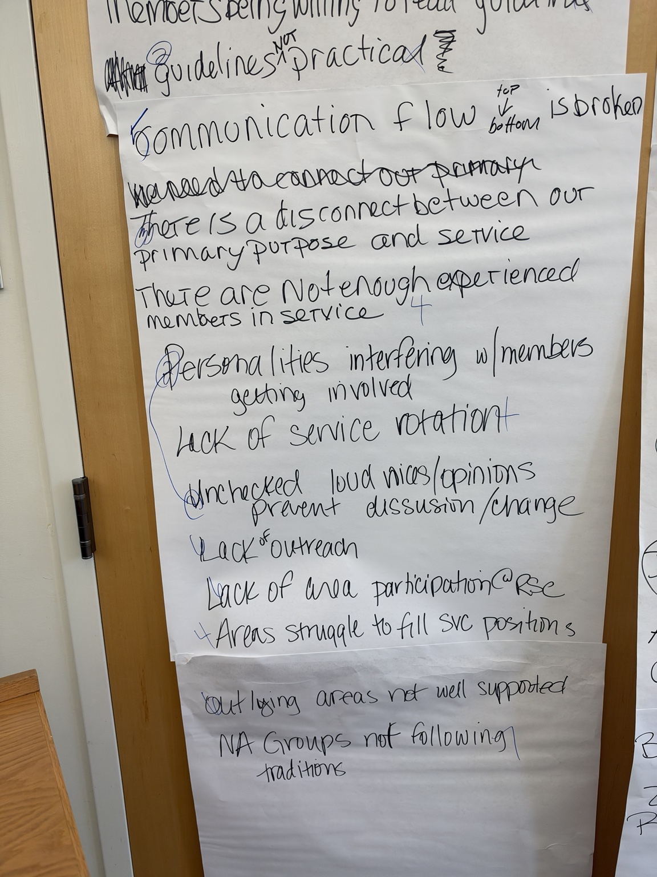

Photograph 3 — IMG_3636.jpeg
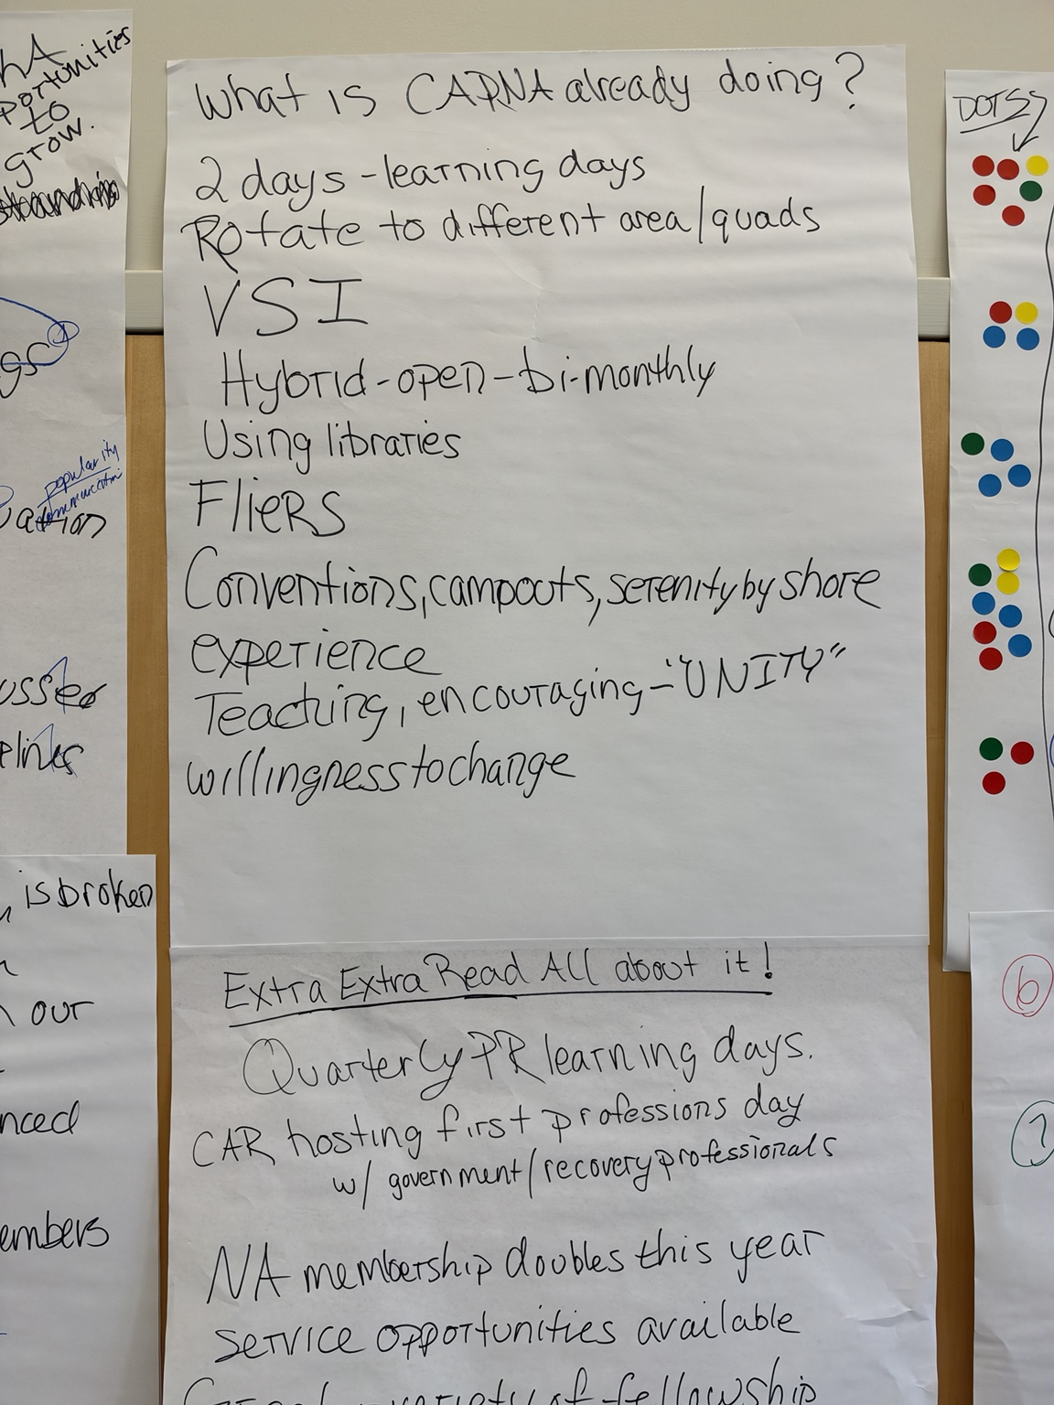

Photograph 4 — IMG_3638.jpeg
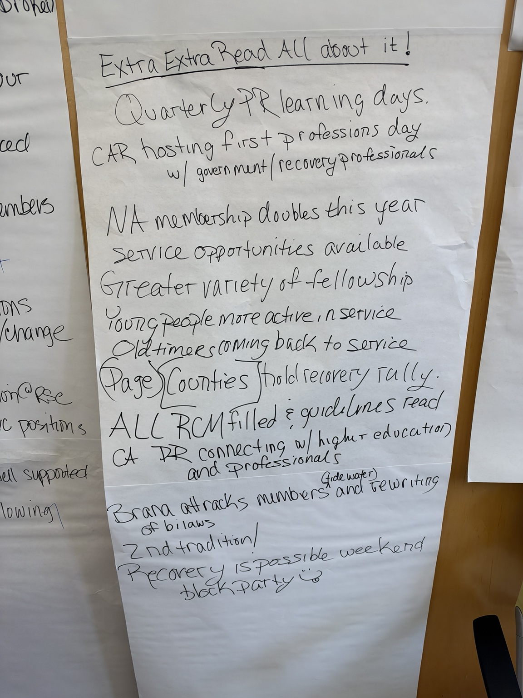

Photograph 5 — IMG_3639.jpeg
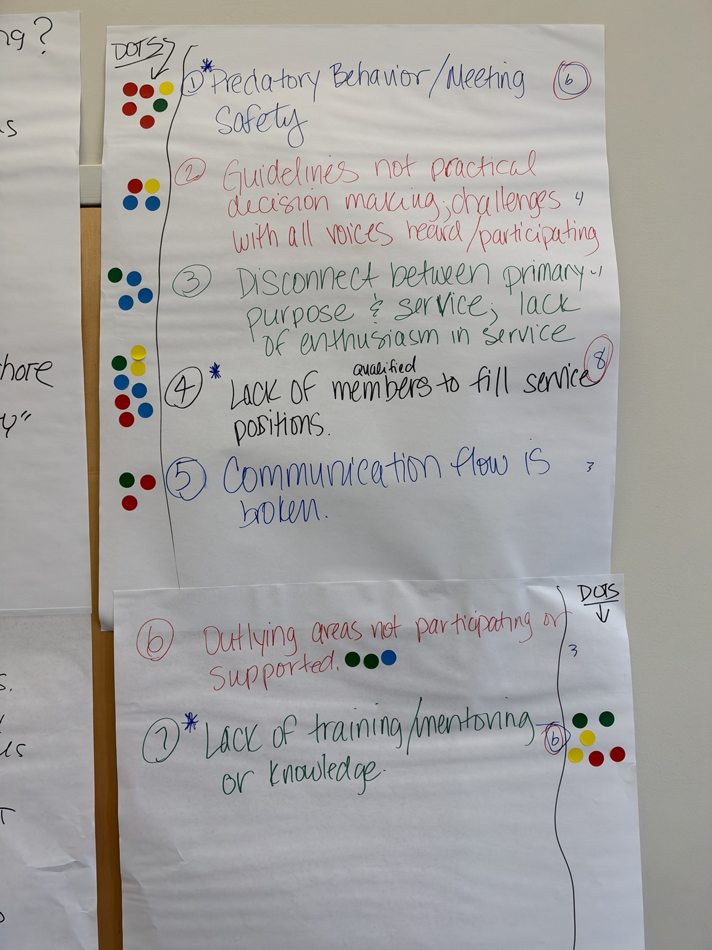

Photograph 6 — IMG_3640.jpeg
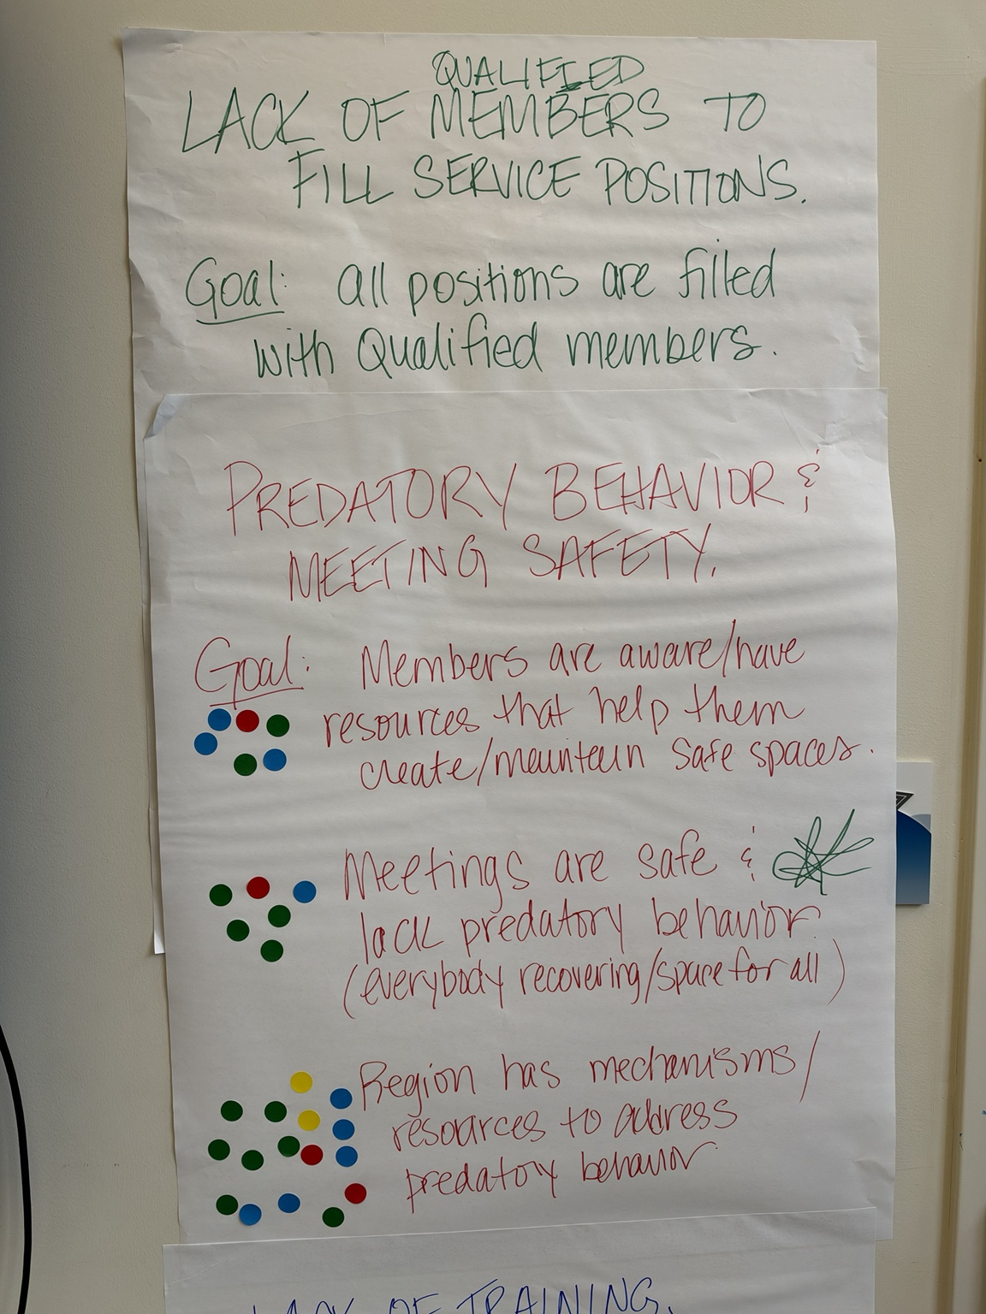

Photograph 7 — IMG_3641.jpeg
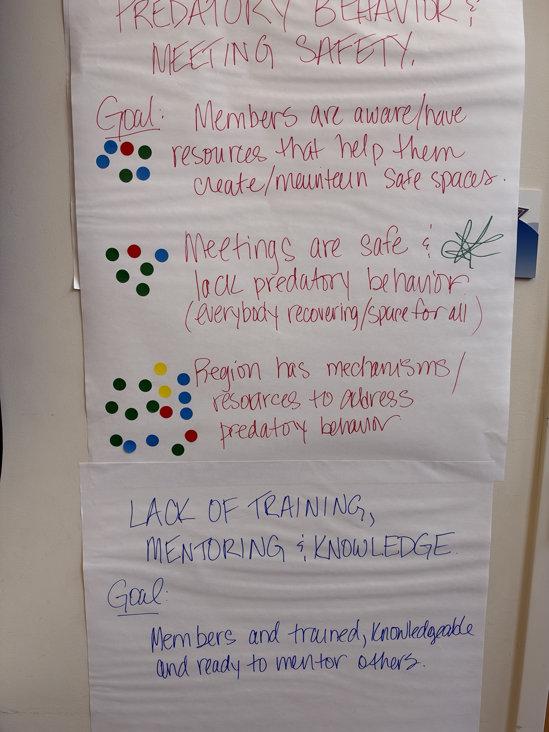

Photograph 8 — IMG_3642(1).jpeg
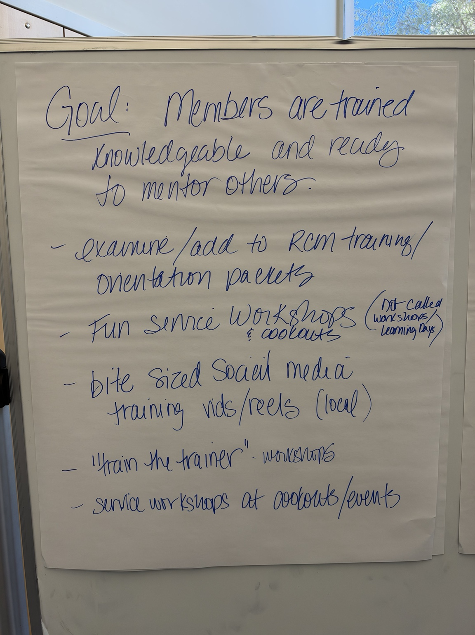

Photograph 9 — IMG_3643(1).jpeg
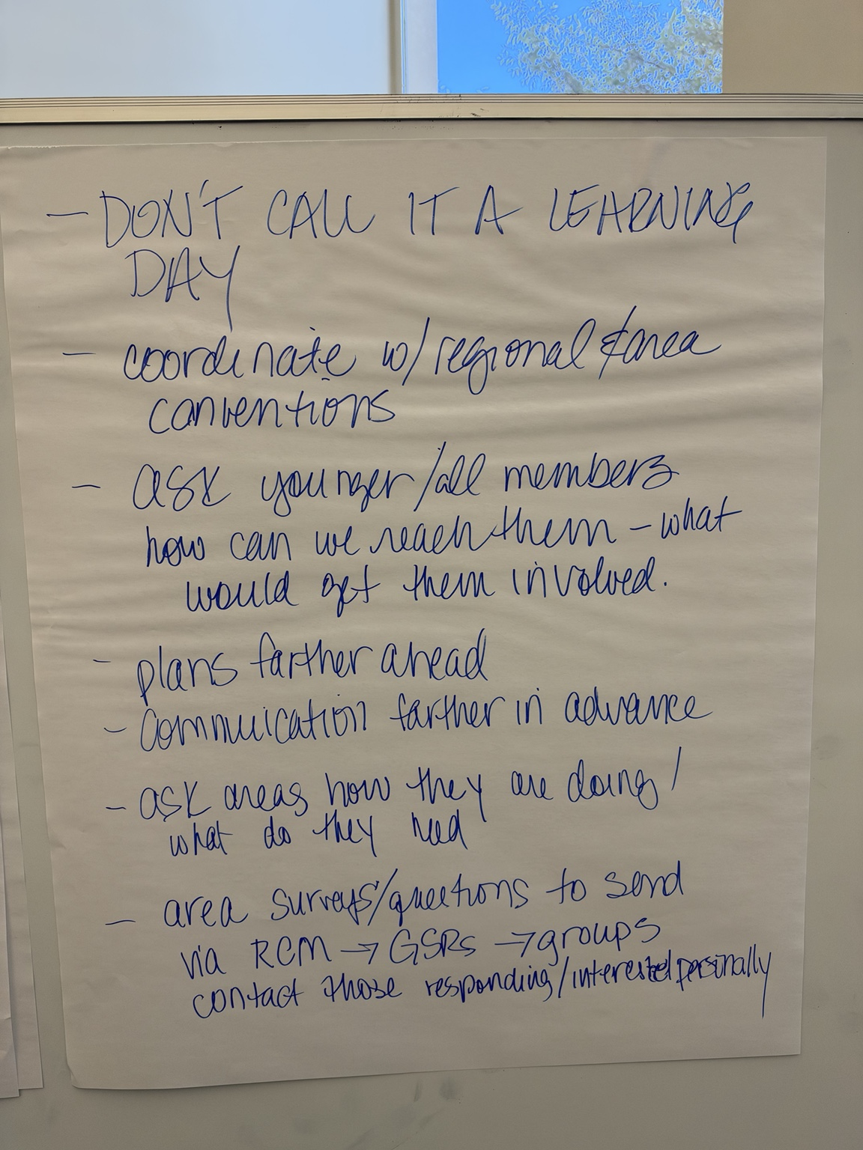

Photograph 10 — IMG_3644(1).jpeg
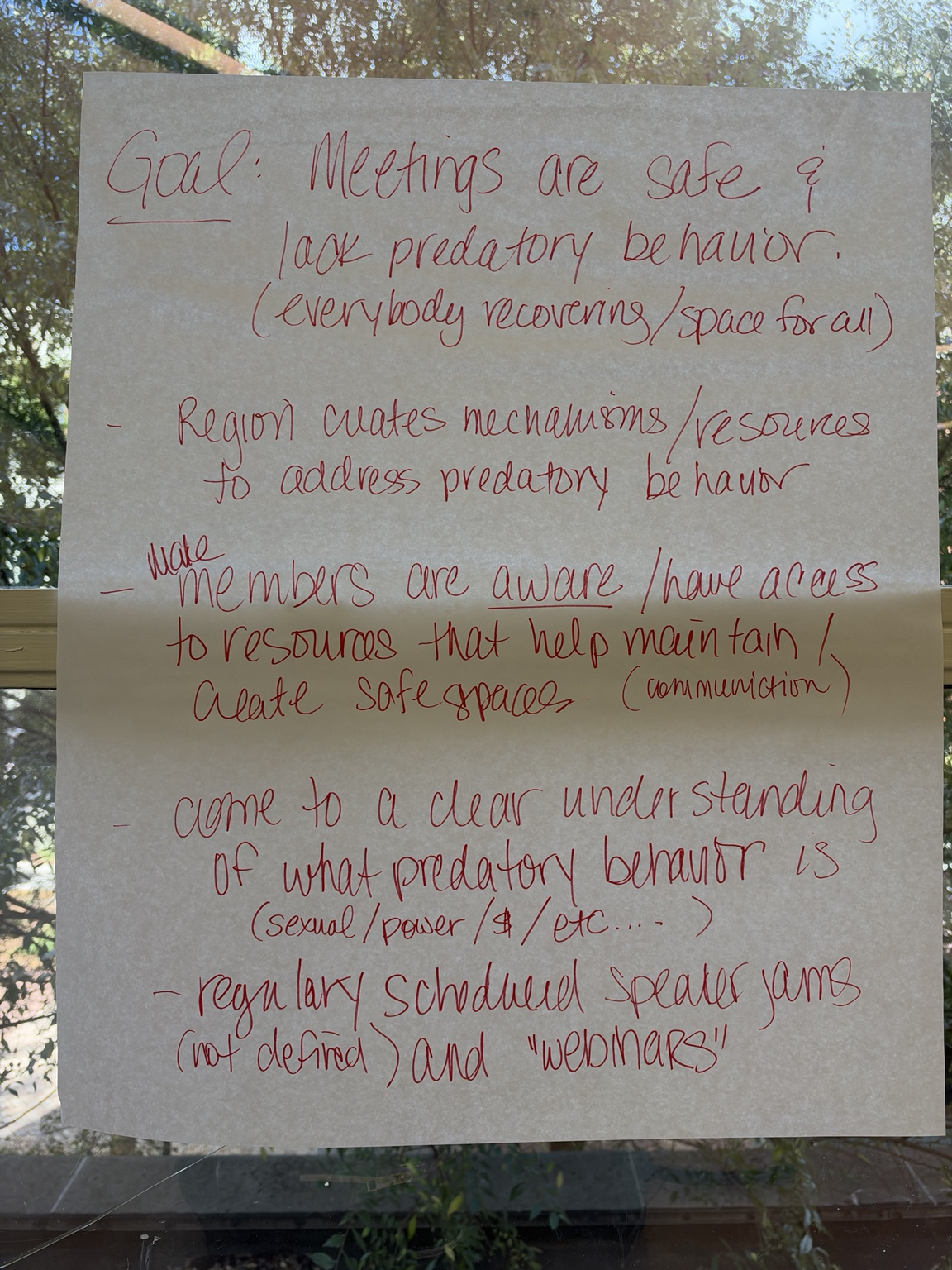

Photograph 11 — IMG_3645(1).jpeg
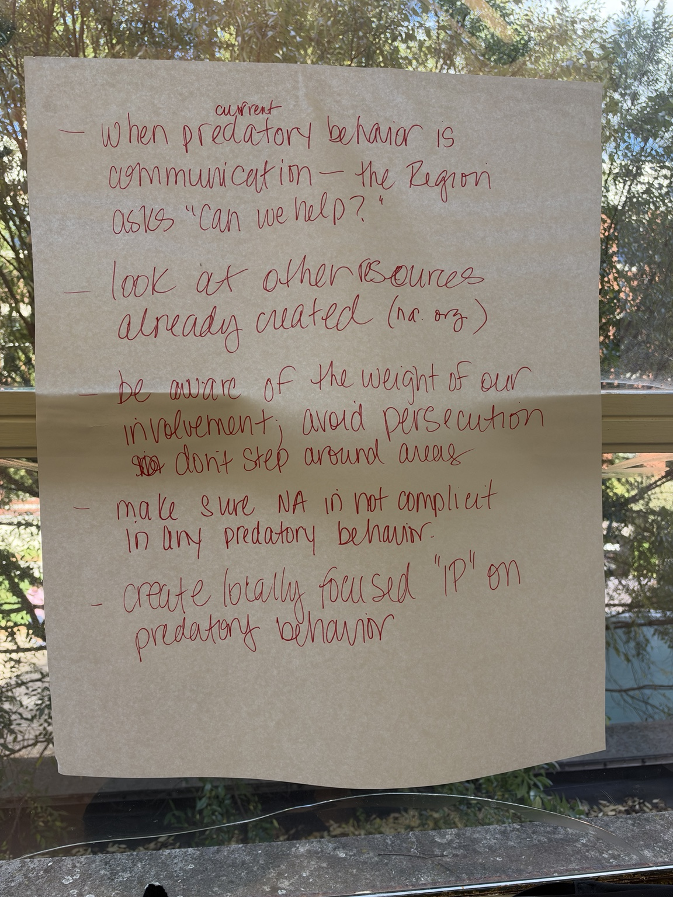

Photograph 12 — IMG_3646(1).jpeg
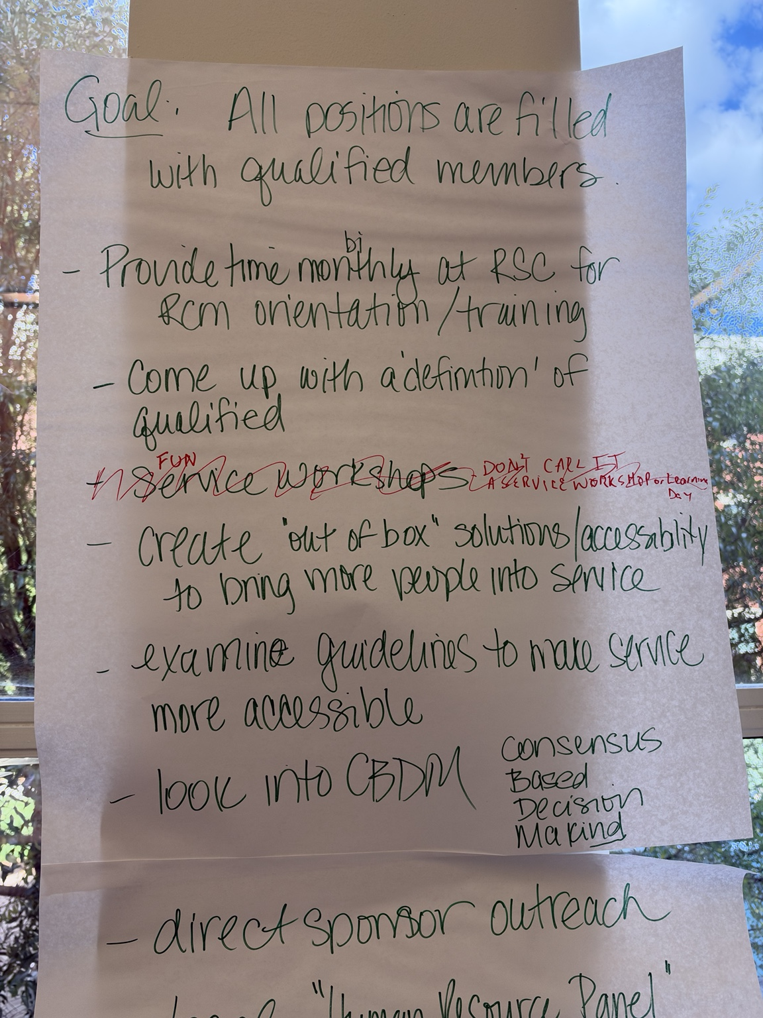

Photograph 13 — IMG_3647(1).jpeg
